**Day 4 Implementation Report**

**Rakshanda’s Closet:**

**This is a women’s clothing brand that aims to provide high quality stitched and unstitched clothes to its customers. We aim to keep affordability in our consideration targeting local and foreign female Pakistanis that could not afford high priced clothes.**

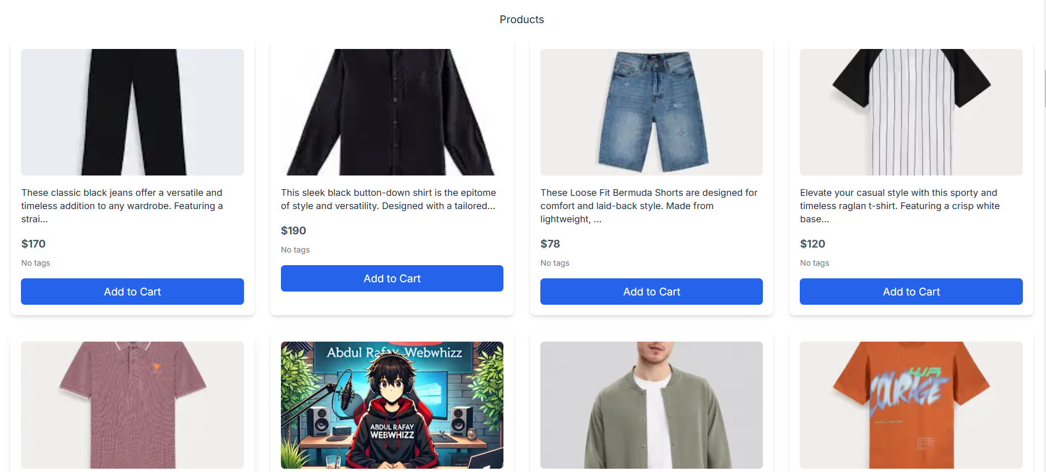

1. **Fetched data from sanity to the front end of the web with add to cart option.**

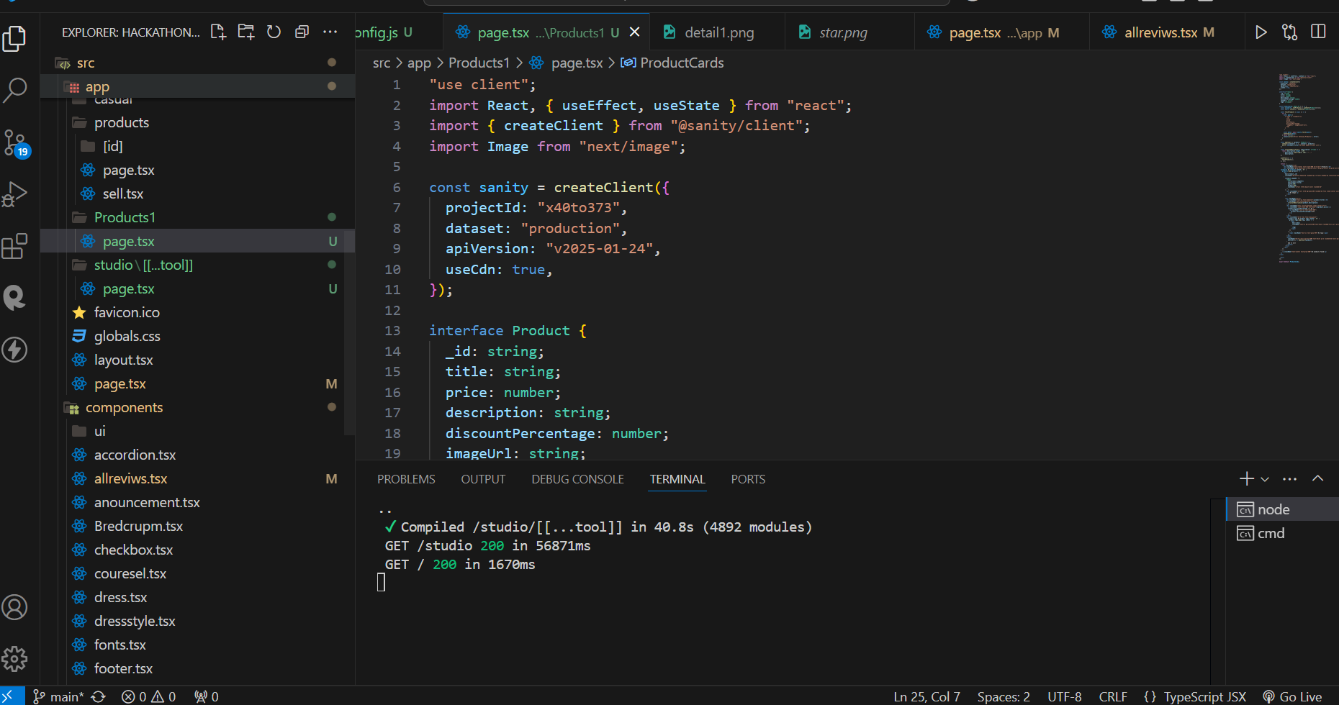

1. **Code for fetching data from sanity with product Cards and Tailwind Css implementation.**

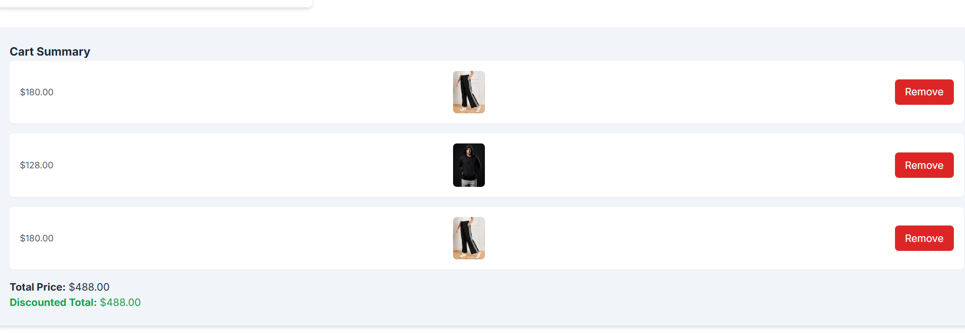

1. **This is the cart summary with add and remove functionality.**

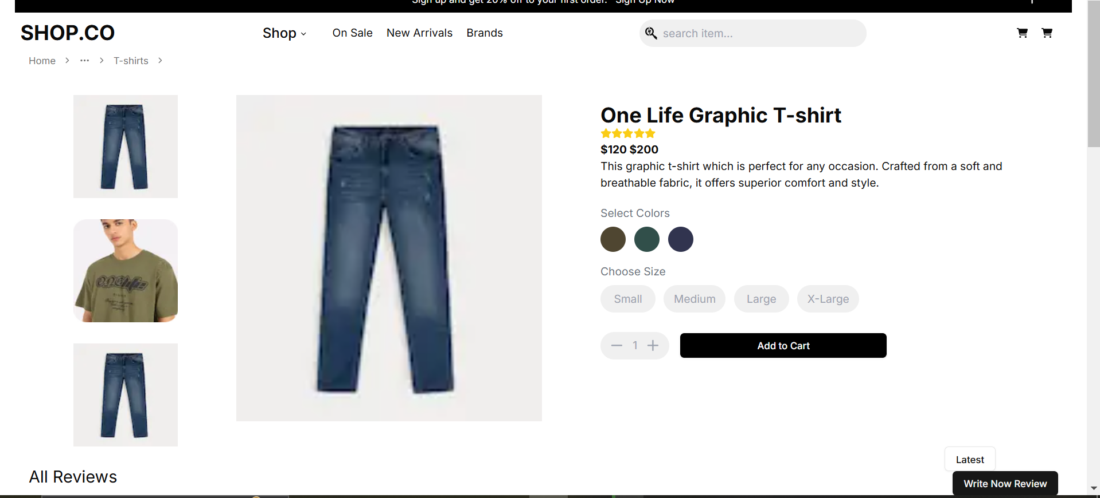

1. **This is the dynamic routing of the products displayed on the front end.**

**Authentication: Integrating it into my website would help me prevent unauthorized access to private information.**

**Payment Integration through stripe would help in securely processing transactions and accepting payments abroad.**

**Conclusion: The website has add to cart component, attractive UI/UX, product data fetched from sanity and the cart summary. The last thing left is payment integration and an AI model that are in progress.**